Data Flow Diagrams and User Stories
Project Name: Medical Diagnosis Center (MDC)
Platform: ServiceNow Service Portal
Team ID: ServiceNow-92 Date: 14 Oct 26

1. Project Overview
The Medical Diagnosis Center (MDC) is a ServiceNow application for organizing diagnostic test information, patient details, appointment bookings, and medical report records. Patients use the portal to browse tests, book appointments, and access report information. Receptionists support patient and appointment management, laboratory technicians update test/report progress, and administrators manage application records and access.

2. Data Flow Diagrams

2.1 Level 0 — Context Diagram
This diagram shows MDC as one system and the information exchanged with its main user roles.
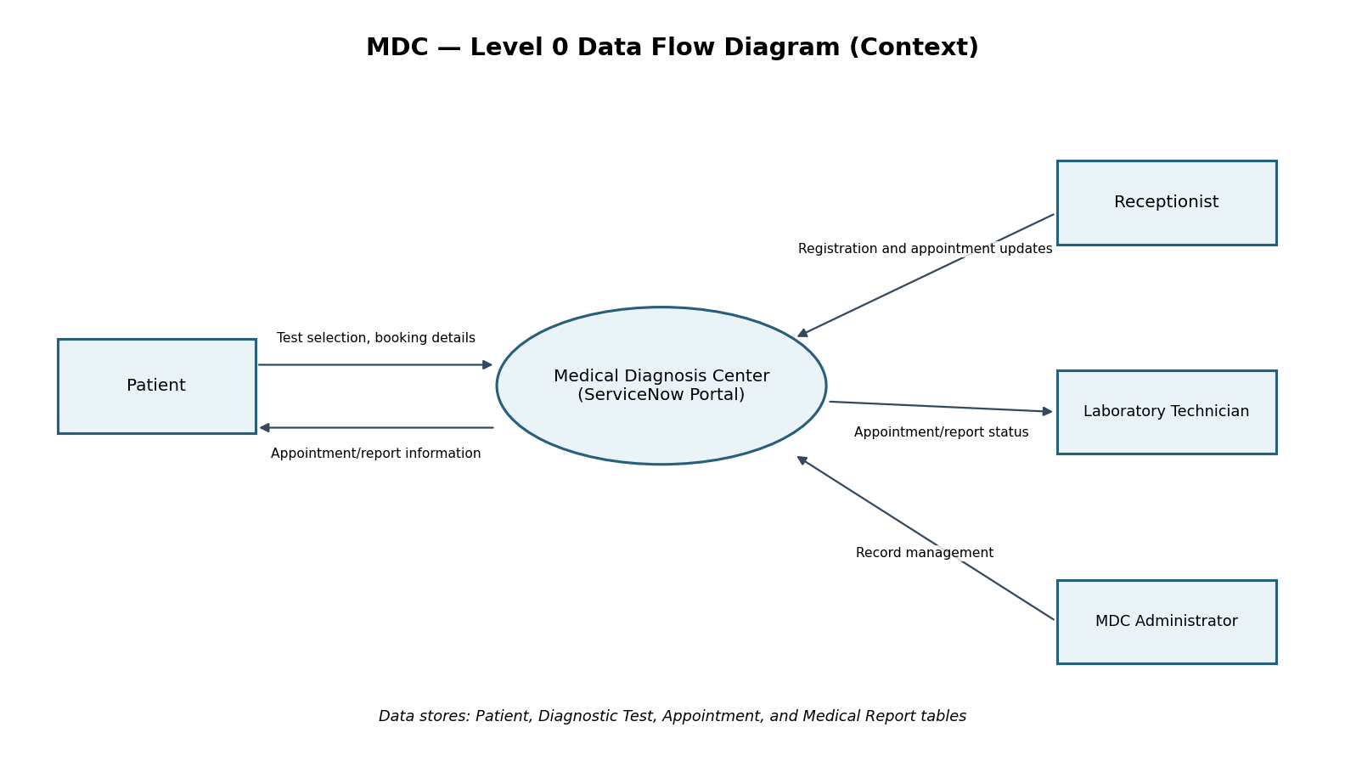

2.2 Level 1 — Processes and Data Stores
This diagram expands MDC into test browsing, appointment management, test/report status updates, and report access.
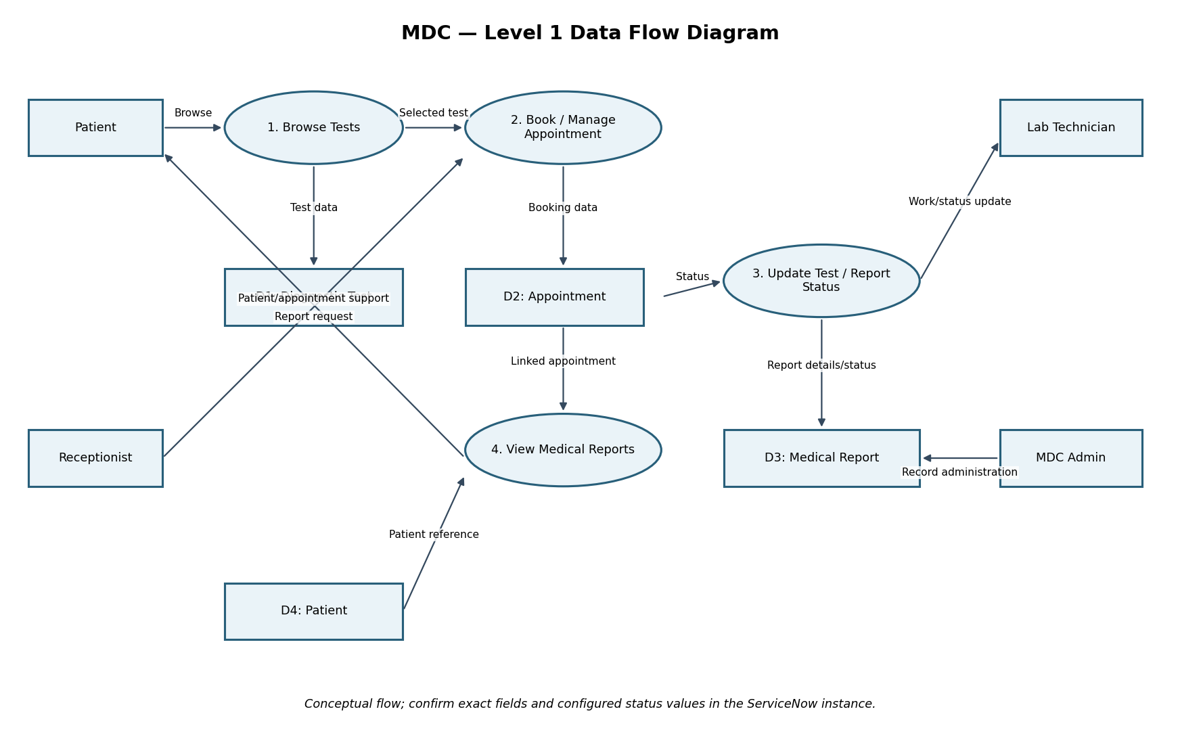

2.3 Data Stores
ID | Table | Purpose
D1 | Diagnostic Test | Stores test names, descriptions, prices, durations, preparation instructions, and active status.
D2 | Appointment | Stores patient/test references, appointment date and time, booking date, and status.
D3 | Medical Report | Stores report details and status linked to an appointment.
D4 | Patient | Stores patient profile information used by the MDC workflow.

3. User Stories
Acceptance criteria describe expected behaviour. Patient-specific access, role permissions, and workflow behaviour should be verified in the ServiceNow instance before they are described as fully enforced.
User Type | Functional Requirement | Story No. | User Story / Task | Acceptance Criteria | Priority | Release
Patient | Browse Tests | MDC-US-01 | As a patient, I want to view available diagnostic tests so I can choose a test. | Active tests and available test details are displayed. | High | Sprint 1
Patient | Book Test | MDC-US-02 | As a patient, I want to submit an appointment request for a selected test. | An appointment record is created with the selected test, patient reference, date/time, and initial status. | High | Sprint 1
Patient | Appointments | MDC-US-03 | As a patient, I want to view my appointment details and status. | The relevant appointment information is displayed to the authorized patient. | High | Sprint 1
Patient | Medical Reports | MDC-US-04 | As a patient, I want to access report information associated with my appointment. | A linked report can be viewed when a report record exists and access is authorized. | High | Sprint 2
Receptionist | Patient Management | MDC-US-05 | As a receptionist, I want to record patient details and support appointment management. | Patient and appointment records can be managed according to configured role permissions. | High | Sprint 1
Receptionist | Appointment Management | MDC-US-06 | As a receptionist, I want to review and update appointment status. | Permitted status changes are saved and shown on the relevant record. | High | Sprint 2
Lab Technician | Test Processing | MDC-US-07 | As a laboratory technician, I want to update diagnostic appointment progress. | Authorized status updates are saved and reflected in the workflow. | High | Sprint 2
Lab Technician | Report Management | MDC-US-08 | As a laboratory technician, I want to maintain report details and status for an appointment. | The report is linked to the correct appointment and can be updated according to permissions. | High | Sprint 2
Administrator | Application Management | MDC-US-09 | As an administrator, I want to manage diagnostic tests and MDC records. | The administrator can perform permitted record-management tasks on MDC tables. | High | Sprint 1
Administrator | Access Management | MDC-US-10 | As an administrator, I want to manage role-based access to MDC functions. | Configured roles control access to relevant pages, records, and actions; this is checked through role-based testing. | High | Sprint 2
Administrator | Workflow Monitoring | MDC-US-11 | As an administrator, I want to review appointment and report records to monitor progress. | Records can be reviewed by their current statuses. | Medium | Sprint 2

4. Assumptions and Notes
- The DFDs are conceptual diagrams, not direct exports from ServiceNow design tools.
- The project's custom table prefix is x_2193703_medica_0; confirm exact table and field names in the instance before making configuration changes.
- Demonstration report findings should not be treated as validated clinical results.
- The appointment date/time workflow has a known time-zone mismatch that requires verification.
- PDF generation, automated email/SMS notifications, online payments, mobile applications, and AI assistance are future enhancements, not claimed as completed features.

